International safe experts meet in Frankfurt
- Around 140 participants from five continents at the ESSA General Assembly
- New area of use for safes: lithium-ion batteries
- Smart locks in safes: technologies, security design, pitfalls
- Sustainability: from responsible safe production to recycling

Frankfurt/M. - 27 Nov. 2023 Once a year, Frankfurt is the safest city in the world: when safe and security experts from five continents meet at the annual General Assembly of the International Security Association (ESSA). Falko Adomat, since April the new Managing Director of the leading international organisation for physical security, welcomed around 140 participants from Europe, North and South America, Asia and Oceania to the Frankfurt on 22 and 23 November. The focus was on trend topics: the current usage behaviour of safe owners, new areas of application, smart locks and sustainable safe production. The ESSA also presented its award for the fifth time.

Usage behaviour: What goes in the safe?
"Are safes only used for cash?" A member survey investigated this question. Falko Adomat on the results: "Although the answers are not representative, they give a rough picture: around a third of private owners primarily store cash in their safes, compared to 63 per cent of business owners." In addition to money and valuables, e-bike batteries with lithium-ion batteries are probably also stored in safes - after all, according to the Federal Statistical Office, there are now 8.4 million electric bikes in Germany. The problem is that not every storage cabinet is suitable for safe battery storage.

New requirement: Storage of lithium-ion batteries
Many manufacturers claim that their cabinets protect against fires - even when storing batteries. However, their claims are usually based on their own classification. In order to achieve reliable, uniform standards, the ESSA has launched the project "Testing and certification of storage cabinets for lithium-ion batteries" together with the VDMA and the ECB. Dirk Etheber from the ECB presented the current status in Frankfurt. The partners first carried out fire tests - the main risks are smoke, fire and explosion. The VDMA 24994 guideline, which is due to be published soon, was developed on the basis of these findings. It specifies test requirements for fire protection cabinets for portable lithium-ion batteries weighing up to 25 kg.

Challenge: Smart locks in safes
The keynote speech by Jens Heider focussed on smart locks in safes. The head of the Testlab Mobile Security department at the Fraunhofer Institute presented the challenges of security. He spoke about objectives, technologies and security design, pitfalls and avoidable vulnerabilities.

Sustainability: climate-neutral safe production and recycling
Sustainability plays a major role in the industry - presentations and workshops shed light on the topic with a view to responsible safe production. "We have three goals: climate-neutral production, extending the lifespan of safes and recycling afterwards," explained Falko Adomat. Anna Feldman from VDMA explained the most important aspects of the transformation process in her presentation. The workshop focussed on how companies can create a climate strategy that meets customer wishes and political requirements.

ESSA Award for Slavka Marinič
For the fifth time, the ESSA has presented an award to important figures in the industry. This year, it went to Slavka Marinič, long-standing managing director of a Slovenian safe manufacturer and ESSA board member from 2005 to 2019. Falko Adomat emphasised her commitment, passion and detailed knowledge: "She has made a special contribution to the continuous development of the industry and promoted certification in Eastern Europe." Text 3.430 Z. incl. blank space.

You can also download the press release here.

BU | Photo no. | Photo
Falko Adomat (left) welcomed around 140 safe and security experts from five continents to the ESSA Annual General Assembly in Frankfurt (right in photo: Steffen Cornelius, Certification Engineer, European Certification Body GmbH) | 266 | 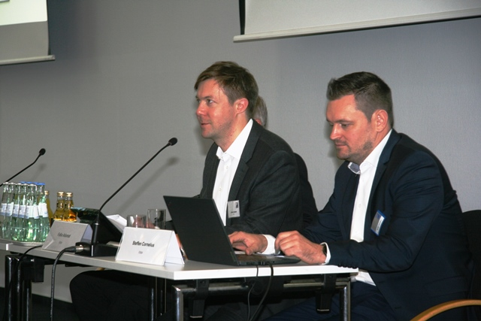
The focus was on trend topics: the current usage behaviour of safe owners, new areas of application, smart locks and sustainable safe production | 267 | 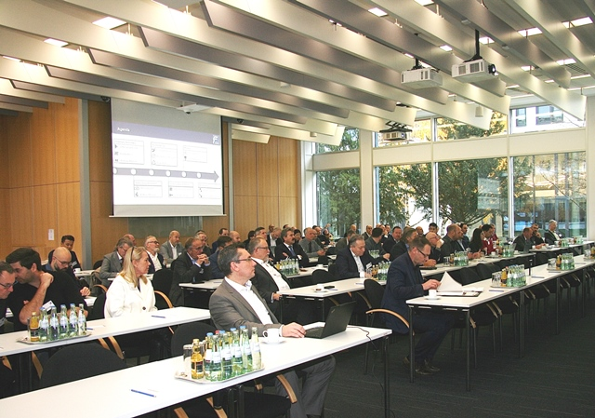
Jens Heider from the Fraunhofer Institute gave a keynote speech on smart locks in safes | 268 | 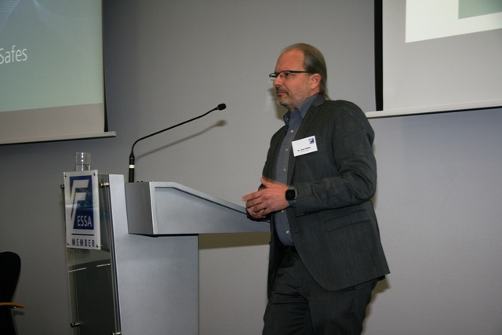
Photo/s: ESSA, Reprint free of charge

Background ESSA
ESSA - The International Security Association is the leading international association of the physical security industry, based in Frankfurt/Main. ESSA currently has over 100 members from five continents.

Data protection and cancellation of press releases
The topic of data protection is highly topical and also of central importance to us. You will receive regular press releases from us on journalistically relevant topics and news. The continued use of your e-mail address for this purpose is based on our business interest in this regard and is carried out on the basis of Art. 6 para. 1 lit. f) GDPR. You can object to your email address being used for this purpose at any time by sending an email to essa@mali-pr.de or by clicking on this link.

