Be careful when buying a safe:
Many certificates are a bluff

Reliable Accreditation of the certification body gives consumers security

Frankfurt/M. – 25. April 2024. Anyone who buys a safe wants security. And that is exactly what is often lacking. The problem is that a number of certificates that buyers use as a guide are a bluff. "In principle, anyone can issue a certificate," says Falko Adomat, Managing Director of the European Security Systems Association (ESSA). "Only the accreditation of the issuing body proves that a neutral, competent organisation is behind it." It is therefore worth taking a closer look or asking: Reliable certification brands have a reference to their accreditation standard. If this information is missing: Hands off!

Risky Security Leak
The risky security leak exists worldwide - worthless certificates are repeatedly found on the global market. While some countries require accredited certifications at least for individual safe applications, others give producers free rein. The result is hollow promises of security. In some cases, certification bodies have not even seen the product, but have only issued their certificate on the basis of drawings. Sometimes the manufacturer has even simply issued the certificate themselves. "Unfortunately, this is not illegal," criticises Falko Adomat.

Accreditation helps with safe selection
The good news is that the reference to accreditation provides consumers with guidance and security. It proves that the independent certification body mentioned works together with competent, neutral test laboratories that have mastered all attack methods when testing safes. Their highly qualified security experts manage extensive, strict testing processes. Based on the results, accredited bodies carry out an unbiased assessment and classification that users can rely on. The international standard ISO/IEC 17065 stipulates that the accreditation body verifies the competence and impartiality of the respective certification body through annual audits.
Text 1.886 Z. incl. blank space

You can also download the press release here.

BU | Photo Nr. | Photo
When buying a safe, consumers should definitely take a close look at the certification mark | 269 | 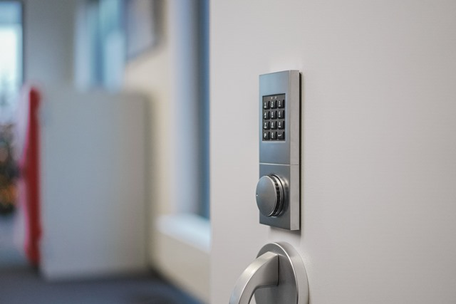
Users can recognise a reliable accredited certification by the ISO/IEC 17065 reference on the certification mark | 270 | 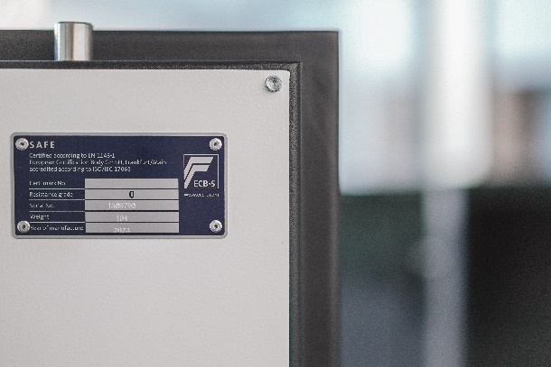
Photo/s: ESSA, Reprint free of charge

Background ESSA
ESSA - The International Security Association is the leading international association of the physical security industry, based in Frankfurt/Main. ESSA currently has over 100 members from five continents.

Data protection and cancellation of press releases
The topic of data protection is highly topical and also of central importance to us. You will receive regular press releases from us on journalistically relevant topics and news. The continued use of your e-mail address for this purpose is based on our business interest in this regard and is carried out on the basis of Art. 6 para. 1 lit. f) GDPR. You can object to your email address being used for this purpose at any time by sending an email to essa@mali-pr.de or by clicking on this link.

