ESSA General Assembly: Meeting place for the world of safes
- More demand: range of applications is growing – from batteries to blockchain
- More uniformity: European laws should be harmonised
- More sustainability: Green production is a long but successful journey

Frankfurt/M. – 12 Nov. 2024. Battery fires, the confusing array of European regulations, digital protection of valuables: at the ESSA's General Assembly, safe and security experts from around the world addressed a wide range of security topics. The association had organised workshops, keynote speeches and presentations for this purpose. Managing Director Falko Adomat welcomed around 140 participants to the meeting in the German city in November. He presented this year's ESSA International Leadership Award to Josef Reingen. The safe expert, who is world-renowned in the industry, has been supporting and promoting the ESSA for over 40 years since 1977, helping it to become a leading international association for the physical security industry.

Fire hazard: store batteries safely
The range of services offered by the security and standardisation segment is growing, and the demands – for example in the area of green production or digital value protection in the blockchain – are increasing. And new segments are emerging, including the fire-protected storage of lithium-ion batteries. ‘This topic only came to our attention through its use in e-bikes and the like,’ says Falko Adomat, managing director of the ESSA. His association has been involved in the new VDMA specification 24994 for testing fire-protected battery storage cabinets. In a workshop, Kevin Walter from the Karlstein Volunteer Fire Department illustrated the importance of safe storage: his unit has had to respond to over 60 battery fires in recent years.

Storage of weapons: no standardised international regulations
The world of European security regulation is anything but harmonious, with each country having its own laws. This was also apparent from the exchange between experts from different nations. In particular, the storage of firearms is by no means uniformly regulated. The ESSA is now striving for harmonisation.

Sustainable safe production requires a change in mentality within the company
Net Zero 2050 – even safe manufacturers have this goal in mind. Markus Hartmann from the company of the same name reported on the long but ultimately successful journey to a lower CO2 footprint. It has already launched a greener safe at the end of 2022. Myriam Bevillon from Gunnebo also described the journey towards decarbonisation as a long-term task that affects all business areas, requires transparency and a change in mentality within the company. In addition to the two presentations, the ESSA presented further sustainability measures from member companies. In early summer, the association had launched a survey on the topic.

Digital assets: crypto wallets also need a safe
The future is digital – but what about the storage of non-analogue assets? Achim Hepp of the German Association for the Digital Economy (BVDW) took a look with the ESSA members at software, hardware and paper wallets that store private keys. His conclusion: high potential, but also a challenge: ‘Crypto wallets need to be stored as well.’ The specialist sees opportunities for partnerships between blockchain security and traditional physical protection in the future.

Text 3.104 characters incl. spaces

You can also download the press release here.

Caption | Photo No | Photo
At the ESSA General Assembly 2024, around 140 safe experts from around the world discussed the growing range of secure storage | 275 | 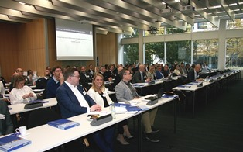
Battery fires are a new risk – the ESSA (photo shows managing director Falko Adomat) has contributed to the new VDMA specification for testing fire-protected battery storage cabinets. | 278 | 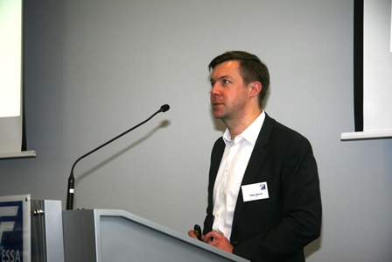
Josef Reingen received this year's ESSA International Leadership Award for his many years of service to fire protection and standardisation. | 273 | 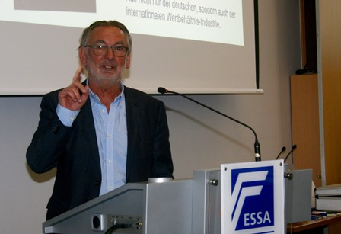
Photo/s: ESSA, Reprint free of charge

Background ESSA
ESSA - The International Security Association is the leading international association of the physical security industry, based in Frankfurt/Main. ESSA currently has over 100 members from five continents.

Data protection and cancellation of press releases
The topic of data protection is highly topical and also of central importance to us. You will receive regular press releases from us on journalistically relevant topics and news. The continued use of your e-mail address for this purpose is based on our business interest in this regard and is carried out on the basis of Art. 6 para. 1 lit. f) GDPR. You can object to your email address being used for this purpose at any time by sending an email to essa@mali-pr.de or by clicking on this link.

